Unit 1: Properties of Matter
Please use the information from the lesson to complete the guided notes right in the Google Doc. You have your own copy of notes for each lesson.

Chemical Storage and Disposal

We are going to start off the course by exploring safety around household and workplace chemicals. Even though household chemicals are available to buy in stores and we often keep them around the house, they still pose many dangers. Many workplaces also require the use of chemicals, so it is important to know the basics to handle them safely.

1. When using chemicals, you should always keep the following questions in mind:
Does the substance have special handling or storage requirements?
How will it react with other substances?
How should it be disposed of?
Is it safe for me to use? Do I need any protective wear?
Common Household Items
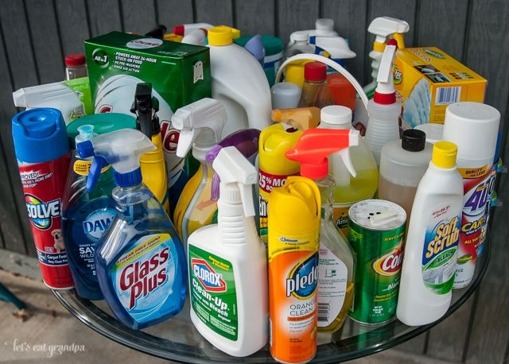

2. WHMIS
WHMIS stands for Workplace Hazardous Materials Information System. It provides information on how to store, safely handle and dispose of chemicals used in the workplace.
All hazardous materials have a WHMIS label, which summarizes safe handling procedures by providing a recognizable symbol.

This means that we do not have to memorize how to safely use and dispose of each chemical; we just have to understand what the symbols on the labels mean

WHMIS Symbols and Meanings:

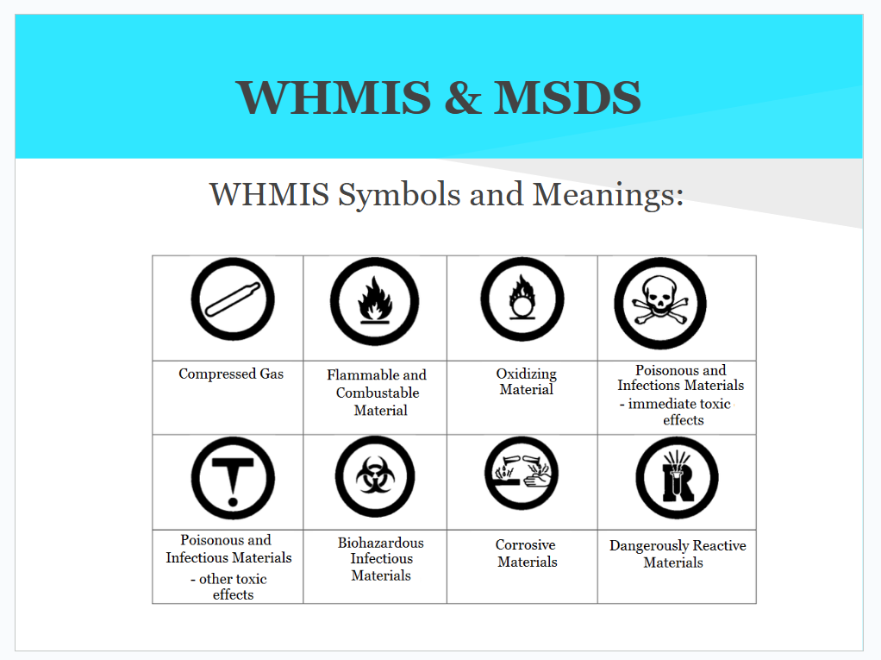

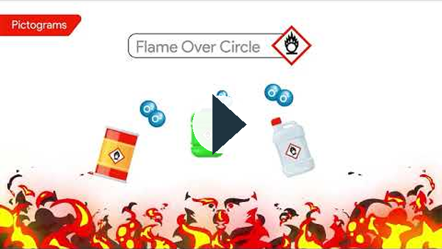
https://www.youtube.com/watch?v=pHYJCm_Ni20

NOTE: Some materials will also have an MSDS (Material Safety Data Sheets) to provide additional detailed information about each chemical. This includes the physical and chemical properties, safe handling, first aid, and disposal procedures.

3. HHPS

HPPS stands for Hazardous Household Products Symbols. You may recognize some of these symbols, as they are more commonly encountered at home as opposed to the workplace, and therefore require a separate system of symbols to represent the dangers they pose.

The next time you are using a chemical at home, check the label to see if there are any of these symbols below:

Common HPPS Symbols
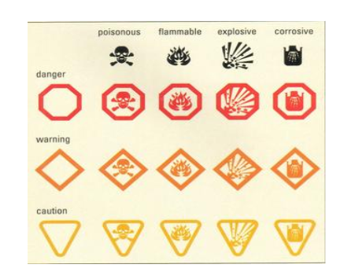
In the image above, notice how the HHPS symbols are designed to look like traffic signs. The symbols, colours, and shapes make them easy to understand.

Even though household chemicals are stored at home, they still pose significant dangers. Many cleaning products should NEVER be mixed. Here are a few examples:

Bleach + Ammonia = Toxic Chlorine Gas - causes shortness of breath & chest pain
Bleach + Vinegar = Toxic Chlorine Gas - causes burning eyes & breathing problem
Hydrogen Peroxide + Vinegar = Peracetic Acid - burns skin, eyes and lungs

Lesson 1 Self-Check
Supporting file: 02_SUPPORTING_FILES_BY_UNIT/01 - Unit 1 Properties of Matter/Lesson 1 Self-Check-4a95d3a9d5.xml
Original package path: ccres0000020/ccres0000020.xml

Lesson 1 Assignment
Supporting file: 02_SUPPORTING_FILES_BY_UNIT/01 - Unit 1 Properties of Matter/Lesson 1 Assignment-1fc0fe9907.xml
Original package path: ccres0000025/ccres0000025.xml
Please use the information from the lesson to complete the guided notes right in the Google Doc. You have your own copy of notes for each lesson.

Classifying and Describing Matter

1. Types of Matter

What is Matter?
Matter is anything that has mass and takes up space in the world around us. Mattter can be organized into two categories:

1. Pure Substances

2. Mixtures

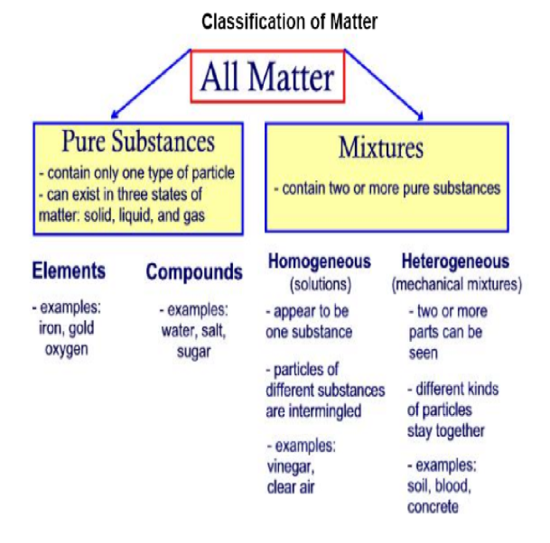
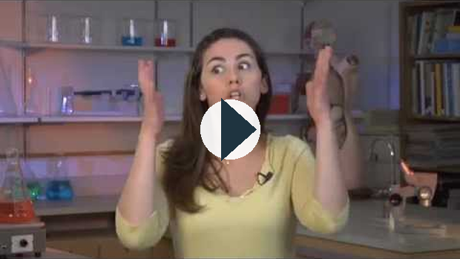
https://www.youtube.com/watch?v=LCIeS5Cwke0

https://www.youtube.com/watch?v=LCIeS5Cwke0

Pure Substances

Pure substances have the following characteristics:
1. Made up of one type of particle - These can be elements such as iron (Fe) and gold (Au) or
compounds such salt (NaCl) or water (H2O)
2. All parts of a pure substance are identical

3. Has a defined chemical formula

4. Can exist in all three states of matter - Solids, Liquids and Gases

2. Mixtures
A combination of two or more substances such that each one’s properties are not lost but may be hidden.

Homogeneous Mixtures - Solutions
- Mixtures that look like they have one set of properties.
- Blended so well that every sample of the mixture will contain an even mixture of all matter that make it up- therefore “homogenous” means every part of the mixture is the same.
- These are what we call “SOLUTIONS” - the molecules of each substance in the mixture slip in between one another.

Examples of Solutions
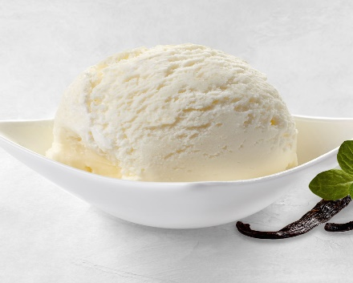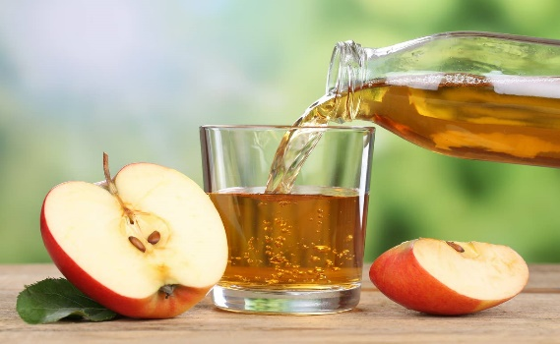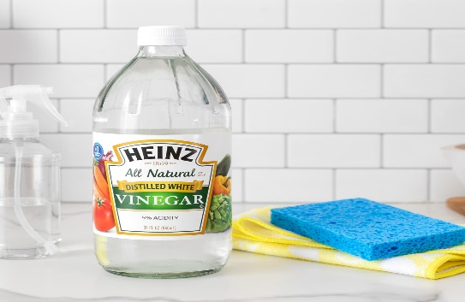

Heterogeneous Mixtures - MECHANICAL MIXTURES
- Mixtures that contain two or more parts that are still visible.
- Means to be made up of parts or mixed. Different components may be visible to the naked eye (e.g. salsa), known as mechanical mixtures, or with a microscope (e.g. juice), known as suspensions.

Example: The properties of minerals in rocks are not hidden. Some minerals might be white, shiny and smooth-black, dull and rough. You can tell that the rock is a mixture and not a pure substance by looking at it.

Examples of Heterogeneous Mixtures
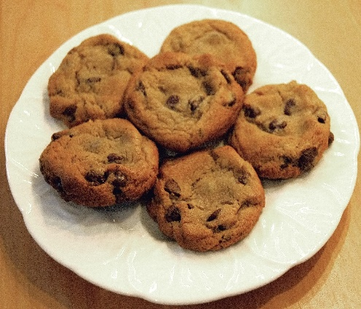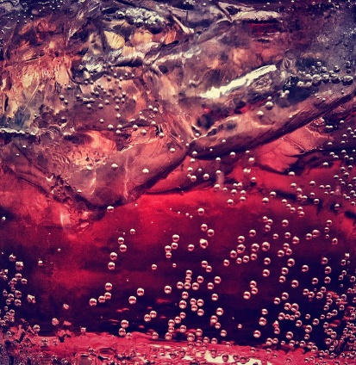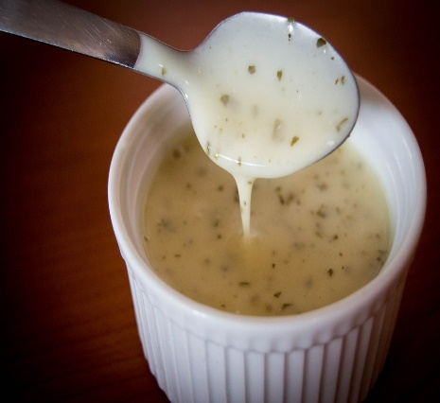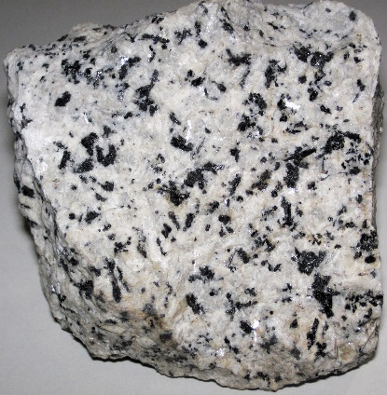

Mixtures


https://www.youtube.com/watch?v=TlxajGi8bAI

Determining whether substances are pure or mixed
Sometimes it can be difficult to tell whether substances are truly pure or mixed. We can examine their appearance, texture, and even density. However, it is often necessary to investigate their boiling and freezing points…

E.g. How do you know if the water you drink is pure?
Mixtures are composed of multiple substances, so they will boil and freeze at different temperatures than the pure substances that make them up. This is how we can test to see if a substance is pure or not.

Lesson 2 - Self Check
Supporting file: 02_SUPPORTING_FILES_BY_UNIT/01 - Unit 1 Properties of Matter/Lesson 2 - Self Check-430c739c43.xml
Original package path: ccres0000021/ccres0000021.xml
Please use the information from the lesson to complete the guided notes right in the Google Doc. You have your own copy of notes for each lesson.

Classifying and Describing Matter Continued........

1. The Particle Theory of Matter:
Anything in the universe that has mass is made up of tiny particles called molecules and atoms. This can be anything from the air we breathe, clothes we wear to a distant star millions of light years away.

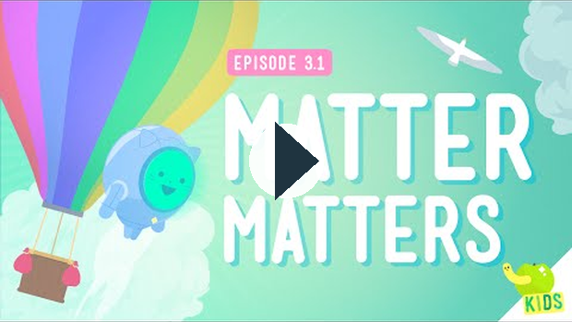
https://www.youtube.com/watch?v=ELchwUIlWa8

The Particle Theory of Matter is made up of the five following rules:
- All matter is made up of very small particles
- All particles in pure substances are the same
- There are spaces between particles; the amount of space varies depending on the state of matter
- Particles are always moving. As particles gain energy, they move faster
- The particles in a substance are attracted to one another

2. States of Matter
Matter may exist in three states, depending on how close together or far apart its particles are…
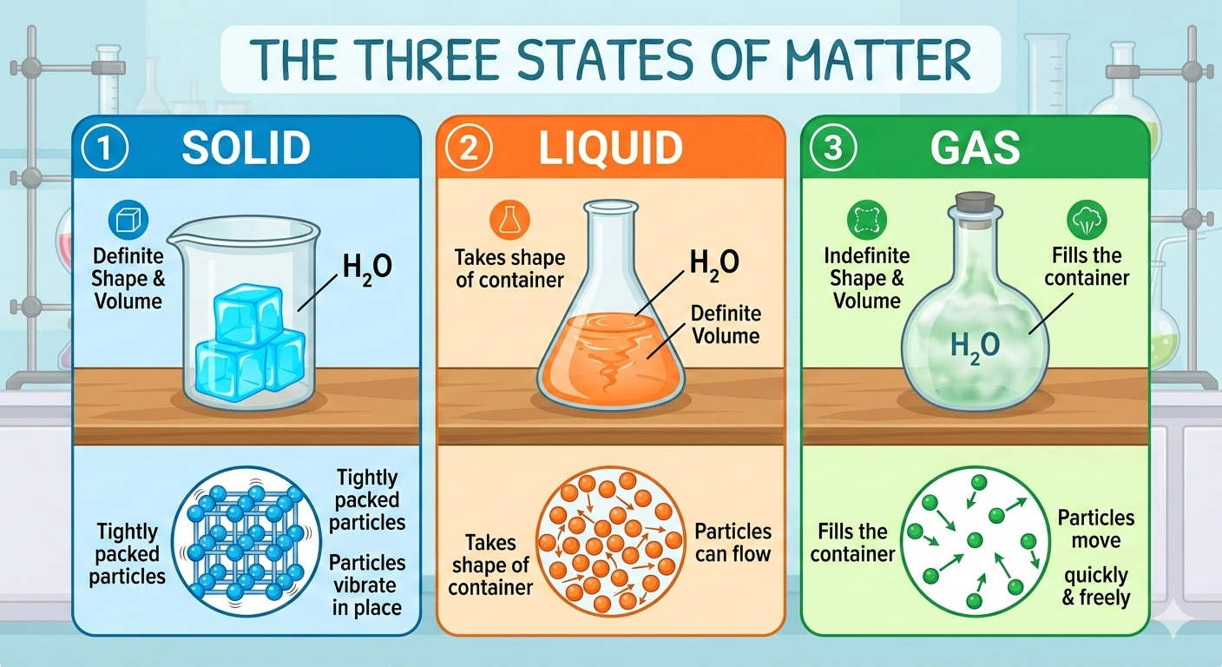

Interacive: The Three States of Matter
Directions: "Launch" the interactive below and the press the play button. Use the orange play button to see how the molecules are arranged and behave in each container for all 3 states of matter


https://interactives.ck12.org/simulations/embed.html?embeded=true&interactive=states-of-matter&subject=chemistry&lang=en&assignment=true

Matter does not exist in a fixed state. That is, solids can become liquids, liquids can become gases, and vice versa.
- When particles gain energy (heat up), they expand (move apart), causing solids to turn to liquid (e.g. ice melts to form water
- When particles gain energy (heat up), they expand even more (move apart), causing liquids to turn to gas (e.g. water is vapourized as it begins to boil)
- When particles lose energy (cool down), they condense (come together), causing liquids to turn to solid (e.g. water freezes to form ice)
- When particles lose energy (cool down), they condense (come together), causing gases to form liquid (e.g. water vapour condenses to form water)

Converting Between States of Matter
Through the addition or loss of energy, matter can change states.

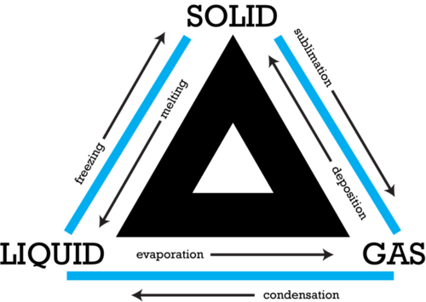

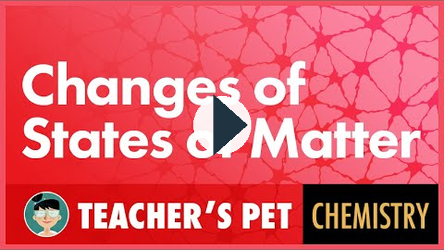
https://www.youtube.com/watch?v=EwzkYTfHFbo
Particle Theory also helps explain other properties of matter...

3. Physical vs. Chemical Properties
Physical Properties of Matter - These can be measured or observed without changing what the substance actually is - the composition of the matter that makes up the substance.
For example: taste, smell, density, freezing or melting point

Chemical Properties of Matter - This is when a substance changes its chemical composition - the combination of molecules and atoms that make up a substance. To observe these properties, we must change what the substance actually is.
For example: flammability, combustion, type of reaction that occurs when combined with other substances

Lesson 3 Self Check
Supporting file: 02_SUPPORTING_FILES_BY_UNIT/01 - Unit 1 Properties of Matter/Lesson 3 Self Check-4f11d141b4.xml
Original package path: ccres0000022/ccres0000022.xml

Lesson 2 and 3 Assignment
Supporting file: 02_SUPPORTING_FILES_BY_UNIT/01 - Unit 1 Properties of Matter/Lesson 2 and 3 Assignment-85768ea28c.xml
Original package path: ccres0000026/ccres0000026.xml
Please use the information from the lesson to complete the guided notes right in the Google Doc. You have your own copy of notes for each lesson.
Solutions and Solubility, Acids & Bases

1. Solutions
Solutions are formed when two or more substances are combined to create a mixture. The mixture appears as one substance. Some examples include apple juice, ketchup, hot chocolate and the air we breathe. Solutions can exist as a solid, liquid or gas.
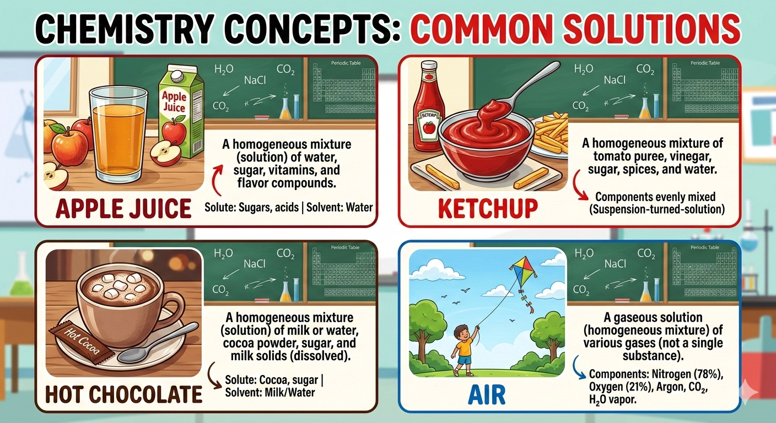

2. Solutes and Solvents
There are several key terms to know about solutions. Lets use a solution made up of sugar and water as an example:
- Solute: is the substance that gets dissolved in a solution. The solute in the example sugar. It GETS dissolved.
- Solvent: is the substance that does the dissolving of a solute in a solution. It's usually the larger amount of the two substances. The solvent in the example is the water. It DISSOLVES the sugar.
- Soluble: means a solute is able to be dissolved in a particular solvent. In the sugar and water example, we would say that “sugar is soluble in water”.
- Insoluble: this term means that a solute is NOT able to dissolve in a solvent In the sugar and water example, the metal spoon you use to stir the solution will NOT dissolve in the water. We say “the spoon is insoluble in water”
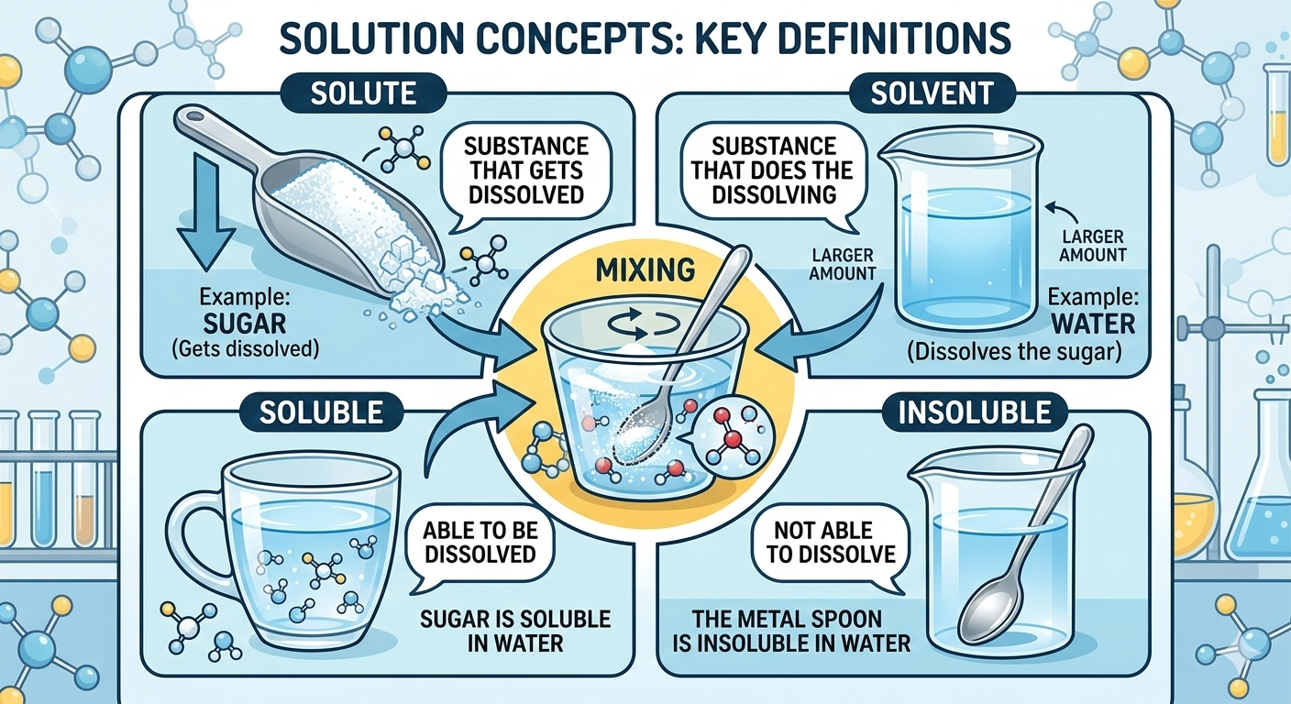

3. How Much Can Be Dissolved?
Solubility is the term used to describe HOW MUCH (mass) of a solute can dissolve in a solvent. It is measured in g/L. For example, we can dissolve 2000g of sugar in one litre of room temperature water. The solubility of water is 2000g/L.
Concentration is the amount (mass) of a solute that is dissolved in a solution. We would say that the concentration of the water is 2000g/L from the example above.
Rate of Dissolving
We can increase how fast and how much of a solute dissolves in a solvent by adding energy to the solution. This can be achieved in two ways:
- Heating up the solvent
- Stirring the solution
Heating up the solvent will also increase the amount of solute (solubility) that can be dissolved. For example, if 1 litre of water is heated up to 80⁰C, we can dissolve approximately 3690g of sugar. This is much higher concentration compared to the room temperature example above.

Concentrated products, such as frozen orange juice, contain a high solute to solvent ratio. This allows us to simply add water (solvent) to make large quantities of the product ready to use.

Concentrated products are beneficial in that they require less packaging than “ready-made” or dilute products:


../02_SUPPORTING_FILES_BY_UNIT/Linked Media/Lesson 4 - Solutions and Solub-fc3ff2597a.mp4

4. Acids and Bases
Solutions can be separated into two groups, acids and bases. This is based on their pH according to the pH Scale.

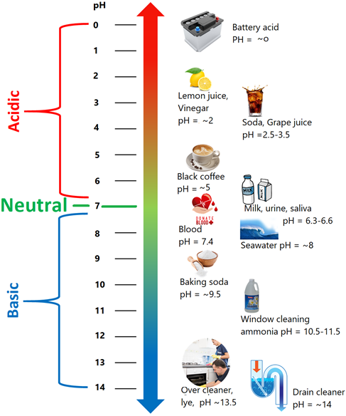

Image Credit

Phet pH Scale Simulator:
Explore the pH of several substances using the simulation below.
1. Move the purple sensor into the beaker.
2. Select the substance you want to test from the drop down menu at the top (water is the first one)
3. Press the red button on the dropper to fill up the beaker

4. Make sure the purple sensor is in the liquid and observe the pH. Is it acidic or basic?
5. Repeat for the other substance in the drop down.

https://phet.colorado.edu/sims/html/ph-scale-basics/latest/ph-scale-basics_en.html

Lesson 4 Self-Check
Supporting file: 02_SUPPORTING_FILES_BY_UNIT/01 - Unit 1 Properties of Matter/Lesson 4 Self-Check-8099c0273d.xml
Original package path: ccres0000023/ccres0000023.xml

Lesson 4 Assignment
Supporting file: 02_SUPPORTING_FILES_BY_UNIT/01 - Unit 1 Properties of Matter/Lesson 4 Assignment-99522a758b.xml
Original package path: ccres0000027/ccres0000027.xml
Please use the information from the lesson to complete the guided notes right in the Google Doc. You have your own copy of notes for each lesson.
Elements, Compounds and the Periodic Table

1. The Periodic Table
If we remember……… elements are pure substances that are made up of only one kind of atom. Throughout history, scientists discovered more and more elements and needed a way to organize them. The periodic table is a chart that organizes all of the elements in a logical way.

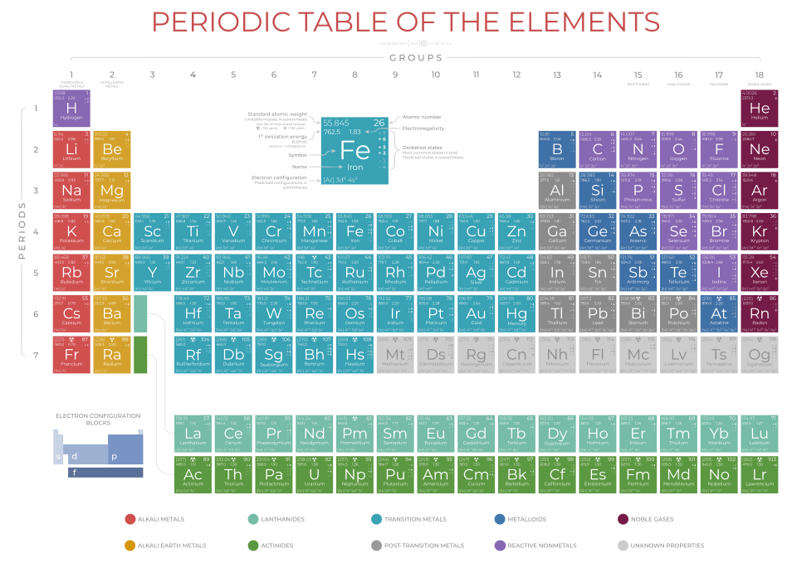

Image Attribution

Watch the video below to learn about the how the periodic table organized.
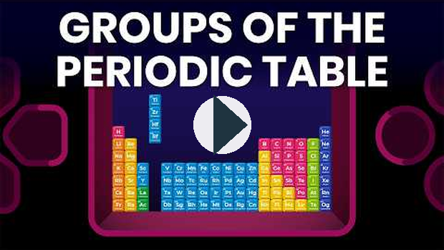
https://www.youtube.com/watch?v=S1VXyXA5ic0
How is it organized?

Rows (Periods)
- Horizontal rows
- Show increasing atomic number
- Elements in the same row have the same number of electron shells

Columns (Groups or Families)
- Vertical columns
- Elements in the same group have similar chemical properties
- They have the same number of valence electrons

2. Compounds
A compound is a molecule that is made up of two or more different elements. Some examples are water (H₂O), sugar (C₆H₁₂O₆) and salt (NaCl). You can see each substance is made up of more than one type of element from the periodic table.
Watch the video below to learn more about compounds.
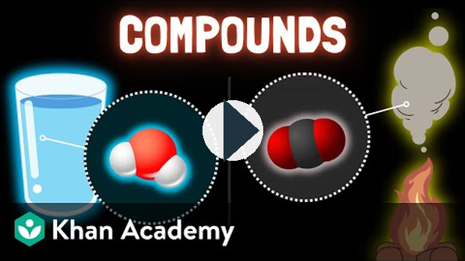
https://www.youtube.com/watch?v=36nlbUdRvUM

Naming Compounds
Many compounds have both a chemical name and a commonly used name. Glucose, for example, is the chemical for a common type of sugar. It can be broken down into its elements.

Chemical Formula for Glucose: C₆H₁₂O₆

We can break this down:

C - Carbon - there are 6 atoms of carbon
H - Hydrogen - there are 12 atoms of carbon
O - Oxygen - there are 6 atoms of oxygen

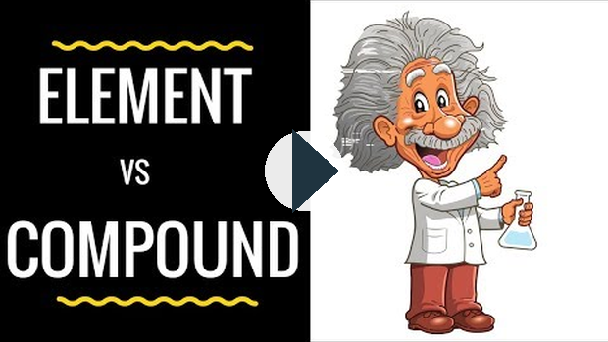
https://www.youtube.com/watch?v=olNaHLbd8zg
Here are a few other examples:
Chemical Formula | Compound Name | Common Name
CaCO₃ | Calcium Carbonate | Chalk
NaHCO₃ | Sodium Bicarbonate | Baking Soda
NaCl | Sodium Chloride | Table Salt

Lesson 5 Self Check
Supporting file: 02_SUPPORTING_FILES_BY_UNIT/01 - Unit 1 Properties of Matter/Lesson 5 Self Check-b99cba639d.xml
Original package path: ccres0000024/ccres0000024.xml

Purpose: You are going create your own superhero from one element off the Periodic Table.

Directions:
- Read through the assignment directions/instructions
- Complete the Periodic Table Research Sheet
- Follow the rubric to make sure you are meeting all of the necessary criteria
- Use your research to create your final product
- Submit your final product

https://docs.google.com/presentation/d/e/2PACX-1vRS5AlvIDKUDjHqrNvTa10YeYwovye98qR00ypYc7dorbJd3M85VOsqaJSZuN3sseYh9k3LrZKrKe4w/pubembed?start=false&loop=false&delayms=5000
Classifying Matter and Using It Safely

1. What Is Matter?
Matter = anything that has mass and takes up space.
Examples: air, water, wood, metal, food, plastics.
We classify matter by its properties (how it looks, behaves, or reacts).

2. Safety with Household Substances
Many household and workplace substances can be dangerous.
WHMIS (Workplace Hazardous Materials Information System): used in workplaces.
HHPS (Household Hazardous Product Symbols): found on household products.

Common Safety Symbols:
Skull & crossbones – poisonous.
Flame – flammable.
Exploding bomb – explosive.
Corrosion – can burn skin/eyes.
Always store chemicals properly, follow labels, and dispose of them safely (e.g., batteries, cleaners, motor oil).

3. Pure Substances vs. Mixtures

Pure Substances
Made of one type of particle only.
Properties are the same throughout.
Examples:
Zinc (metal)
Pure water (H₂O)
Acetic acid

Mixtures
Made of two or more substances combined.
Can be uniform (homogeneous) or non-uniform (heterogeneous).
Examples:
Brass = copper + zinc (alloy).
Stainless steel = iron + carbon + other metals.
Vinegar = water + acetic acid.
Salt water = water + dissolved salt.

4. Real-Life Applications
Salting icy roads: lowers the freezing point of water → melts ice faster.
Antifreeze in car radiators: prevents water from freezing in winter and boiling in summer.
Alloys (like stainless steel): stronger, rust-resistant, used in construction and tools.
Mixtures often have properties more useful than the pure substances they’re made from.

5. Physical vs. Chemical Properties

Physical Properties
Can be observed without changing the substance.
Examples: color, density, melting point, boiling point, conductivity, hardness.
Ice melting = physical change (still water).

Chemical Properties
Describe how a substance reacts with other substances.
Examples: flammability, reactivity with acid, rusting, decomposition.
Rusting iron or burning wood = chemical change (new substances formed).

6. Particle Model of Matter
The particle model explains matter in terms of tiny particles always in motion:
Solids: particles tightly packed, vibrate in place → fixed shape, not easily compressed.
Liquids: particles close but can slide past each other → take the shape of container, not easily compressed.
Gases: particles far apart, move freely → expand to fill container, easily compressed.
Temperature affects particle motion: higher temperature = faster movement = more energy.

Key Takeaways
Matter can be classified into pure substances and mixtures, each with unique properties.
Safety is critical → use WHMIS and HHPS symbols for safe handling, storage, and disposal.
Physical properties describe appearance/behavior; chemical properties describe how substances react.
The particle model helps explain states of matter and changes in them.
Solutions, Solubility, and Acids & Bases

1. Key Terms
Solution – a homogeneous mixture (looks the same throughout).
Solvent – the substance that does the dissolving (usually present in larger amount).
Solute – the substance being dissolved (usually present in smaller amount).
Solubility – how much solute can dissolve in a solvent at a certain temperature.
Example: In salt water, water = solvent, salt = solute, and together they make a solution.

2. Examples of Solutions

Homogeneous solutions (evenly mixed):
Vinegar (acetic acid in water).
Sugar in tea or coffee.
Air (oxygen + nitrogen gases).
Not homogeneous (don’t mix evenly):
Oil + water.
Sand in water.
Salad dressing (if it separates).
3. Temperature and Solubility
Solids in liquids: dissolve better at higher temperatures.
- Example: More sugar dissolves in hot tea than cold tea.
Gases in liquids: dissolve better at lower temperatures.
- Example: Soda goes flat faster when warm (gas escapes).
Particle Model Explanation:
Higher temperature → particles move faster → solute particles mix more easily into the solvent.
But for gases, higher temperature makes particles move too fast → escape from the liquid.
Real-life uses:
Pickling brine: high concentration of salt solution preserves food.
Syrups for canning: high sugar concentration prevents spoilage.

4. Packaging & the Environment
Concentrated products (like frozen orange juice or concentrated fabric softener) use less packaging because water is added later by the consumer.
Diluted products (ready-to-drink juice) need larger bottles → more packaging waste.
Recycling and waste reduction: choosing concentrates helps reduce packaging materials and environmental impact.

5. The pH Scale
pH measures how acidic or basic a solution is.
Scale runs from 0 → 14:
pH < 7 = acid (sour, corrosive) → lemon juice, vinegar.
pH = 7 = neutral → pure water.
pH > 7 = base (bitter, slippery) → baking soda, soap.
Strong acids (pH ~0-2) and strong bases (pH ~12-14) can be very dangerous.

6. Corrosive Effects of Acids, Bases, and Salts
Acid rain: corrodes metal, stone, and harms ecosystems.
Ocean salt spray: rusts cars and bridges near coastlines.
High humidity + salt: speeds up rusting of iron.
Bases (like strong cleaners) can also break down materials and irritate skin.

7. Dangers of Mixing Chemicals
Never mix household cleaners without knowing what they contain.
Bleach + ammonia cleaners → toxic chlorine gas (very dangerous).
Acids + water: always add acid to water, never water to acid (prevents splattering).
Industrial and household accidents often come from improper chemical mixing.

Key Takeaways
Solutions are made of solutes dissolved in solvents.
Solubility depends on temperature and the type of solute/solvent.
Concentrated products reduce packaging waste → help the environment.
pH shows if something is an acid or base.
Acids, bases, salts, humidity, and temperature can corrode materials.
Safety first: never mix bleach and ammonia, and always handle acids carefully.
Elements, Compounds, and the Periodic Table

1. Elements and Compounds
Element: a pure substance made of only one type of atom.
Examples: hydrogen (H), oxygen (O), carbon (C), sodium (Na).
Compound: a substance made when two or more elements chemically combine.
Examples:
Water (H₂O) = hydrogen + oxygen.
Salt (NaCl) = sodium + chlorine.
Carbon dioxide (CO₂) = carbon + oxygen.
Compounds can be broken down into their elements, but elements cannot be broken down into anything simpler.

2. Properties of Metals, Nonmetals, and Metalloids

Metals (left side of periodic table)
Shiny (luster).
Good conductors of heat & electricity.
Malleable (can be hammered into sheets).
Ductile (can be stretched into wires).
Usually solid at room temperature.
Example: iron, copper, aluminum.

Nonmetals (right side of periodic table)
Dull (not shiny).
Poor conductors (insulators).
Brittle (break easily if solid).
Many are gases at room temperature.
Example: oxygen, sulfur, carbon.

Metalloids (border between metals & nonmetals)
Have properties of both metals and nonmetals.
Some are shiny but brittle.
Can sometimes conduct electricity (semiconductors).
Example: boron, silicon.

3. Using the Periodic Table
The periodic table organizes elements by:
Atomic number (number of protons).
Groups (columns) – elements with similar properties (e.g., Group 1 = very reactive metals).
Periods (rows) – elements with gradually changing properties.
From the table, you can find:
Name, symbol, atomic number, atomic mass, state of matter, and general properties.

4. Word Equations for Common Compounds
Word equations show how elements combine to form compounds:
Hydrogen + Oxygen → Water
- (2H₂ + O₂ → 2H₂O)
Iron + Oxygen → Rust (Iron oxide)
- (4Fe + 3O₂ → 2Fe₂O₃)
Carbon + Oxygen → Carbon dioxide
- (C + O₂ → CO₂)
Sodium + Chlorine → Salt (Sodium chloride)
- (2Na + Cl₂ → 2NaCl)
Word equations are the “sentence version” of chemical reactions.

Key Takeaways
Elements are pure substances; compounds are made of elements joined together.
Metals, nonmetals, and metalloids have different physical and chemical properties.
The periodic table helps locate elements and predict their behavior.
Common reactions (like rusting or burning) show how elements combine into compounds.

